|  |  |
| --- | --- |
| **Model** | **Root Mean Squared Error (RMSE)** |
| Auto Regressive (Univariate Analysis) | 2.91 |
| ARIMA (Univariate Analysis) | 2.36 |
| LSTM (Univariate Analysis) | 1.15 |
| LSTM (Multivariate Analysis) | 0.63 |

**Performance of Different Models on Same Test Data:**

1. **Auto Regressive (AR) and ARIMA [Univariate Analysis]**

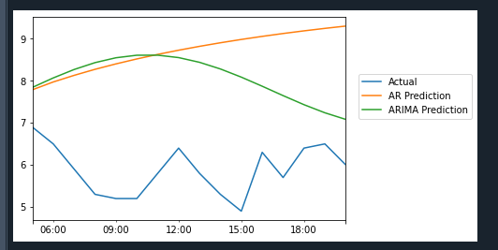

1. **LSTM (Univariate Analysis)**

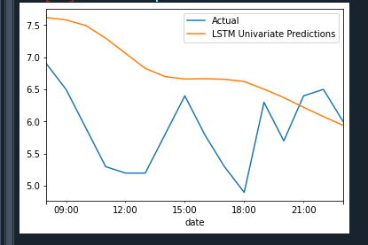

1. **LSTM (Multivariate Analysis)**

